Pokhara University

Level: Bachelor | Semester – Spring | Year : 2009
Programme: BE |  | Full Marks: 100
Course: Numerical Methods |  | Pass Marks: 45
 |  | Time : 3hrs.

Candidates are required to give their answers in their own words as far as practicable.
The figures in the margin indicate full marks.

Attempt all the questions.

 | - Use False- position method to find the root of the following equation, correct upto two decimal places:  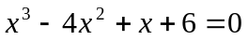  - Find the root of the equation 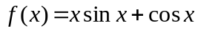using Newton-Raphson method, correct up to three decimal places. | 8  7
 | - The velocity distribution of the fluid near a flat surface is given by the table below:  Where x is the distance from the surface. Using a suitable interpolation method, obtain the velocity at x =2.5  - Use regression method to fit the geometrical curve 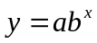to the data given below and obtain the value of y at x =5.5 | 8  7
  X (cm) | 0.1 | 0.3 | 0.5 | 0.7 | 0.9
  V (cm/s) | 0.72 | 1.81 | 2.73 | 3.47 | 3.98
  X | 0 | 1 | 2 | 3 | 4 | 5 | 6 | 7
  Y | 10 | 21 | 35 | 59 | 92 | 200 | 400 | 610
 | - Evaluate the following integral using Simpson's 3/8 Rule: 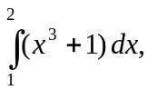using n = 3.  - Evaluate the integral 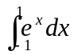using two-point Gauss Legendre method. | 8  7
 | - Solve the following system of equation by Guass-Seidel method (upto 3 iterations only)  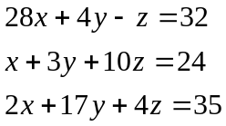  - Solve the following system of equation by Jacobi-Iteration method 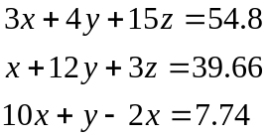 | 8  7
 | - Use the Rk4 method to estimate y(0.5) of the following equations with h = 0.25  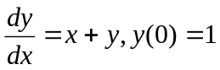  - Solve the second order differential equation  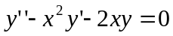for y(0.1) and y'(0.1), given that y(0) = 1, y'(0)=0 using Heun's method Take step size h = 0.1 | 7  8
 | - Solve the elliptic equation Uxx+Uyy = 0 for the following square mesh with boundary values as shown in the figure. Iterate until the maximum difference between two successive values at any point is less than 0.001.  - Determine the largest eigen value and corresponding eigen vector of the following matrix.  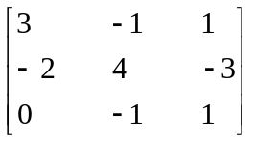 | 8  7
 | Write short notes on: (Any Two)  - Gaussian Qudrature method  - Lagrange's Interpolation method  - Errors in Numerical calculation | 2×5

